TO: Residents of Deschutes County
FROM: John Hummel, Deschutes County District Attorney
DATE: April 10, 2020
RE: Law Enforcement Use of Force Incident on March 9, 2020
INTRODUCTION
On March 9, 2020 at approximately 4:00 AM, Bend Police Sergeant Tommy Russell and Bend Police Officer Tim Williams intentionally shot their guns at 29-year-old Bend resident Danielle Bower. Rounds from both guns struck Ms. Bower. The officers’ decisions to shoot their guns were legally justified.
FACTS
During the early morning hours of March 9, 2020, Bend Police Officer Jacob Koehler was at St. Charles Hospital in Bend to execute a search warrant to draw blood from a suspect in an impaired driving investigation. Bend Police Officer Tiago Oliveira was at the hospital to assist Officer Koehler.
At 2:47 AM, Bend Police Sergeant Tommy Russell heard a radio call from Officer Koehler asking for assistance Code 3 at the hospital. Koehler reported that a white minivan with a female driver was heading toward the hospital exit, had run over curbs, and had almost struck security guards. The driver of this minivan was Danielle Bower.
Moments before Officer Koehler radioed for Code 3 assistance, Danielle Bower had driven up to the entrance of the St. Charles emergency room in her minivan at 2:45 a.m. She entered the emergency department with blood on her face, shirt, and hands. Security personnel asked her if she was okay. She did not respond, but waved them outside to her minivan. She then opened the passenger rear door, showing them the empty child car seats in the second and third rows of the van. When asked what was wrong, she responded, “My family left me. They jumped out. They left me.” She then walked to the driver’s side of the minivan and got into the driver’s seat. The security guard stood in the open door frame, preventing Ms. Bower from closing the door while Bend Police Officers were summoned.
When Officer Oliveira approached the minivan, Ms. Bower closed the minivan door and put her vehicle in drive. Officer Oliveira told her not to drive away and yelled “stop!” and “don’t do it!” The security guard attempted to grab the keys out of the ignition. Ms. Bower failed to comply and drove her minivan between a parked car and a bike rack and up onto a grassy berm. She continued over a curb and into the parking lot and drove west on the hospital’s internal loop on the north side of the hospital. Officer Koehler radioed the description of the vehicle and the location and direction of travel to other officers.
When Sgt. Russell heard Officer Koehler’s call for a code 3 response, he was approaching St. Charles from the North. He entered the hospital property off of NE Purcell Blvd., activated the overhead lights and siren on his marked police vehicle, and immediately started driving east bound on hospital’s internal loop road in the direction he believed would enable him to intercept the minivan before it exited the property. Sure enough, as he approached the RV parking area of the hospital, Sgt. Russell saw the minivan driving on the loop road toward him. He then saw the minivan abruptly and aggressively swerve directly into his lane of travel. Sgt. Russell was forced to take a quick, evasive maneuver to avoid being struck. He steered hard to his right, driving off of the roadway into a grassy area off of the loop road. Sgt. Russell narrowly avoided the minivan, then got back on the roadway, executed a U-turn, and started his pursuit on the loop road.
Ms. Bower ran three stop signs on the loop road, then turned right onto Williamson Road without stopping, all with Sgt. Russell close behind with his lights and siren activated. Ms. Bower then crossed Neff Road without stopping at the stop sign, continued south on Williamson and accelerated quickly, creating space between her and Sgt. Russell.
At this point, Sgt. Russell believed Ms. Bower had committed the crimes of Recklessly Endangering Another Person, Reckless Driving, and Fleeing or Attempting to Elude a Police Officer.
As Ms. Bower reached the residential area of Williamson Road she reached her left hand out of the window of her minivan and extended her middle finger, conveying to Sgt. Russell the well-known message that she was “flipping him off” or “giving him the finger.” After “flipping off” Sgt. Russell, Ms. Bower swerved her minivan back and forth on the roadway, from curb to curb, prior to turning left on Paula Dr.
As they approached Purcell Blvd., Sgt. Russell radioed to his colleagues to prepare to use spike stripes to end the pursuit. Ms. Bower then turned left on Purcell Blvd., running the stop sign. Bend Police Officer Victor Umnitz joined the pursuit on Purcell and fell in behind Sgt. Russell. Ms. Bower ran the stop sign at HWY 20 and continued on Purcell south of HWY 20.
Ms. Bower made a quick left turn on Twin Knolls Dr., then a quick left into the parking lot of Xcel Fitness, then a quick right back onto Purcell Blvd, then a quick left onto HWY 20.
Once on HWY 20, Deschutes County Sheriff’s Deputy Jason Wall joined in the pursuit. Sgt. Russell requested Deputy Wall perform a Pursuit Intervention Technique (PIT maneuver) because he was concerned for the safety of the public and thus wanted to end the pursuit. A PIT maneuver is a technique law enforcement officers are trained in and involves a pursuing car striking a fleeing car in the rear quarter panel, forcing the fleeing car to turn sideways abruptly, causing the driver to lose control and stop.
Deputy Wall radioed his watch commander, Lt. Mike Sundberg, seeking authorization to perform the PIT. Lt. Sundberg denied the request because he understood Sheriff’s Office policy to not allow PITs to be performed on vehicles with high centers of gravity, and he believed Ms. Bower was driving an SUV.
The pursuit then continued into the downtown area. Ms. Bower turned right on Wall Street then right on Lafayette. On Lafayette, Ms. Bower again stuck her left arm out of her window and “flipped off” the pursuing officers. Ms. Bower then turned right on the Bend Parkway.
Sgt. Russell again radioed for assistance with spike strips. Ms. Bower at this point was swerving back and forth, from curb to curb, across both southbound lanes of the parkway.
As the pursuit approached Powers Road, due to the danger to the public, and because Lt. Sundberg had caught up to the pursuit and saw that Ms. Bower was driving a low center of gravity minivan, he authorized a PIT to be performed. Deputy Wall then maneuvered his patrol car so the passenger side front bumper of his car made contact with the driver’s side rear of the minivan. The minivan started to rotate until the rear right tire struck the curb which prevented the full spin out of a vehicle that a PIT is designed to achieve.
Ms. Bower regained control of her minivan, continued south on the Parkway, then drove over the median of the parkway, and fled northbound on the Parkway and then right on Pinebrook Blvd.
Deputy Wall’s vehicle was disabled due to the PIT and thus dropped out of the pursuit. Bend Police Officer Umnitz was the lead pursuit vehicle and he was followed by Sgt. Russell.
After turning right on Pinebrook, Ms. Bower’s sped up and turned left onto Third Street. She ran the red lights at Reed Lane and Brosterhous Road. She turned right on Reed Market while once again extending her left arm out the window and flipping off the pursuing officers.
Ms. Bower entered the 15th Street roundabout and exited north on 15th Street. As previously mentioned, Sgt. Russell had been asking his colleagues to attempt to set spike strips to disable Ms. Bower’s minivan, but due to frequent changes in her direction of travel, no spikes were successfully deployed (spikes were set on HWY 97 just south of Romaine Village Way, but Ms. Bower changed direction before the pursuit went in that area). On 15th Street, Corporal Frickey saw an opportunity to set the spikes and was out of his car attempting to do so, alas, Ms. Bower’s minivan passed his location before he was able to get them set.
Ms. Bower continued north on 15th Street and turned right on HWY 20. After turning on HWY 20, she again swerved back and forth from curb to curb across both lanes of travel.
After she crossed 27th Street, Ms. Bower accelerated to 60 MPH, and reached speeds in excess of 70 MPH as she passed Powell Butte Highway. At Powell Butte Highway, Sgt. Russell asked dispatch to contact the Oregon State Police, the Harney County Sheriff, and the Hines Police Department to request their assistance laying spike strips. Shortly thereafter, dispatch responded that none of these departments had officers on duty in the area the pursuit was heading.
At this point, Bend Police Officer Tiago Oliveira joined the pursuit and asked for permission to pass Ms. Bower’s minivan so he could get far ahead of the chase and lay spike strips. Sgt. Russell denied the request due to his concern about the risk of injury to Officer Oliveira and Ms. Bower during the passing process (because of her previous weaving across lanes of travel and general reckless driving).
Sgt. Russell then radioed that all officers with the exception of himself, Officer Williams, and Officer Umnitz needed to head back to the City of Bend in order to ensure the City was adequately patrolled and protected. Deschutes County Sheriff’s Lieutenant Sundberg had been trailing the pursuit from a distance and he continued to do so.
Sgt. Russell then asked dispatch to obtain the contact information for the registered owner of the minivan so that person could be contacted (hoping the registered owner was driving the van so she could be encouraged to stop).
While dispatch and other officers were attempting to locate the contact information for the registered owner, Ms. Bower swerved into the oncoming lane of travel in front of an oncoming car before swerving back into her lane at the last second. After this near miss, Sgt. Russell contacted Corporal Jeff Frickey to discuss whether to call off the pursuit. Corporal Frickey told Russell the pursuit should continue due to the danger Ms. Bower posed to other people on the road.
At milepost 15, Sgt. Russell asked dispatch to contact the Burns Police Department for assistance. The response was that Burns had no officers on duty.
Sgt. Russell then directed officers to go to the home of the registered owner of the minivan.
At mile post 24, Ms. Bower swerved off the roadway but was able to steer back on the road and continue to flee.
Corporal Frickey talked to the registered owner of the minivan at her home and learned that she had recently sold the van.
Around this time, Ms. Bower again crossed the center line and drove head on into the path of an oncoming vehicle. This time the vehicle was a tractor trailer. At the last second the driver of the tractor trailer jerked his rig to the right, onto the shoulder, and Ms. Bower jerked her car to the right, narrowly avoiding a collision.
Dispatch then radioed that the name of the likely driver of the minivan was Danielle Bower. Sgt. Russell immediately directed officers to go to her house.
At milepost 34, Ms. Bower continued to swerve across the east and west bound lanes of travel. And she again drove in the path of an oncoming tractor trailer, causing the driver of the tractor trailer to have to drive onto the shoulder to avoid a collision.
Officer Oliveira made contact with Ms. Bower’s fiancé at her house and then called Ms. Bower from her fiancé’s phone. Ms. Bower did not answer. It turns out that her phone was still at her house.
Ms. Bower’s minivan then went off of the southbound side of HWY 20 into a ditch, but she was able to drive the car back onto the roadway and continue to flee.
Shortly thereafter, Ms. Bower drove off the northbound side of HWY 20, down a small embankment, and her minivan came to rest upright, on a soft dirt surface. Sgt. Russell then drove slightly ahead of Ms. Bower’s car and he noted the front wheels of her front-wheel drive minivan spinning in the dirt. Sgt. Russell radioed that she appeared stuck.
Sgt. Russell stopped his car, lit up Ms. Bower’s minivan with his spotlight, and exited his patrol car. Officer Williams, stopped his patrol car behind Sgt. Russell’s car, and Officer Umnitz stopped his car behind Officer Williams. All three walked toward Ms. Bower’s minivan: Sgt. Russell approached from the front of the minivan, Officer Williams approached from the passenger side of the minivan, and Officer Umnitz and his K-9 approached from the driver’s side rear of the minivan.
The below picture depicts Ms. Bower’s minivan off the road, Sgt. Russel’s black patrol car toward the left of the picture, and Officer Umnitz’s white patrol car toward the center of the picture (Officer William’s patrol car was parked between these two patrol cars but is not in the picture because it was used to transport Ms. Bower to the hospital, as described later in this document, and Lt. Sundberg’s patrol car is out of the shot to the right):
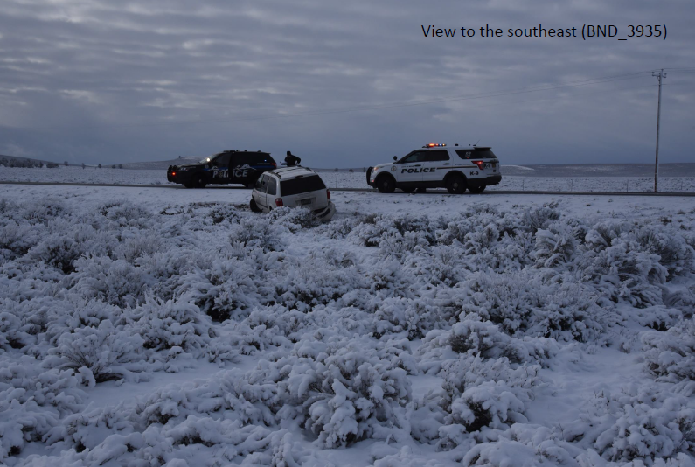
Officer Umnitz and his K-9 partner approached the minivan from the rear driver’s side in anticipation of Ms. Bower attempting to jump out of the van and flee on foot. As he approached the minivan, Officer Umnitz yelled: “Get your hands up! Get your hands up now!” After yelling this, and when he was approximately 5-6 yards behind the minivan, Officer Umnitz saw the backup lights of the minivan come on, heard the vehicle accelerate like the gas was “floored” and saw the vehicle jerk backwards toward him. Lt. Sundberg was a witness to this incident and he confirms Officer Umnitz’s account.
Seconds before Officer Umnitz saw the minivan accelerate toward him, Officers Williams and Sgt. Russell saw Ms. Bower put her hand on the column shifter and move it to the left, into the “reverse” position. When she did this, Sgt. Russell drew his pistol and yelled “stop!” at her. Officer Williams already had his rifle deployed as he approached the minivan. Sgt. Russell and Officer Williams then saw the minivan quickly accelerate backwards in the direction of Officer Umnitz and his K-9.
When the minivan accelerated backwards, Sgt. Russell and Officer Williams shot their guns in the direction of Ms. Bower. Sgt. Russell shot eight rounds. Officer Williams shot six rounds. Ms. Bower was struck by four-five bullets (at least one from each officer) as well as shrapnel from shattered bullets and windshield and side window glass. When interviewed, Sgt. Russell and Officer Williams said they discharged their weapons to prevent Ms. Bower from striking Officer Umnitz with her minivan.
This picture shows some of the entry locations into the minivan from the rounds shot by the officers:
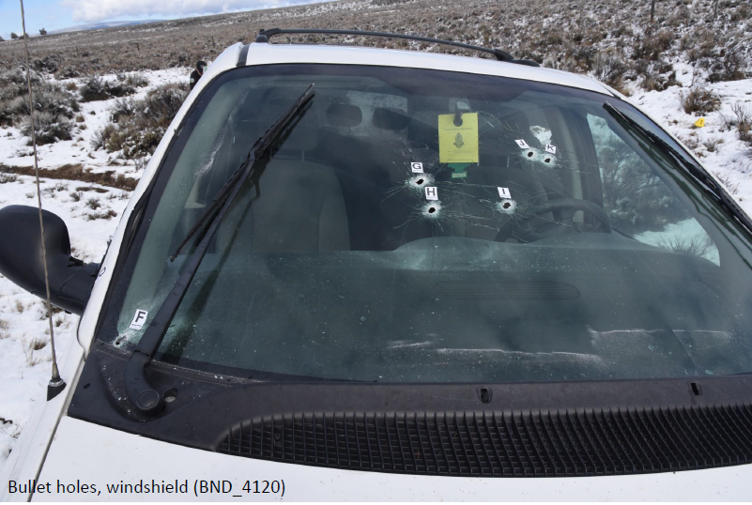
Once Ms. Bower’s minivan stopped moving, Sgt. Russell and Officer Williams stopped firing their weapons. Sgt. Russell thought Officer Umnitz might have been hit by the minivan so after he stopped firing he ran toward Officer Umnitz in order to render aid if needed. Sgt. Russell quickly saw that Officer Umnitz was fine so radioed for the Airlife helicopter to be sent to the scene for Ms. Bower, and he and Officer Williams then ran to render aid to her.
Sgt. Russell used a knife to cut off Ms. Bower’s seatbelt and then removed her from the minivan. He then applied a tourniquet to her bleeding arm. At this point dispatch announced that due to adverse weather conditions, Airlife declined the mission. Sgt. Russell then decided that Ms. Bower could not wait as long as it would take for a ground ambulance to reach the scene so he and Officer Williams loaded her into the back seat of Officer Williams’ patrol car.
Officer Williams sat in the back with Ms. Bower and rendered medical aid to her while Sgt. Russell drove code 3 west on HWY 20 back toward the city limits of Bend. During the drive Officer Williams practiced breathing with Ms. Bower and continually told her to hang on. Ms. Bower was telling him she wanted to see her kids again.
17 miles into this race to the hospital Sgt. Russell met up with the ground ambulance that had been dispatched to the scene. On the side of the road, Ms. Bower was transferred from the patrol car to the ambulance and was then transported to St. Charles Hospital in Bend. Officer Williams rode in the ambulance with Ms. Bower and held her IV bag along the way.
This pursuit started at St. Charles Hospital at 2:47 AM and ended with shots fired at 4:01 AM.
LEGAL ANALYSIS
There is no question that Sgt. Russell and Officer Williams attempted to shoot Danielle Bower, and in fact did shoot her. The only question is whether they were justified in doing so. In other words, to find that either or both of them unlawfully assaulted Ms. Bower, the state would have to prove beyond a reasonable doubt that either or both of them were not justified in their use of deadly physical force. ORS 161.055; State v. Waller, 22 Or App 299 (1975).
Oregon’s Self-Defense Law
Oregon Revised Statutes 161.209 and 161.219 constitute Oregon’s law regarding the use of deadly physical force against another person. This law applies equally to law enforcement and the public. These statutes authorize a person to use physical force against a person: “[F]or self-defense or to defend a third person from what the person reasonably believes to be the use or imminent use of unlawful physical force, and the person may use a degree of force which the person reasonably believes to be necessary for the purpose.”
These statutes restrict the use of deadly physical force against another person to situations where the person is: “committing or attempting to commit a felony involving the use or threatened imminent use of physical force against a person; or * * * using or about to use unlawful deadly physical force against a person.”
Both Sgt. Russell and Officer Williams state that they discharged their weapons to stop Ms. Bower from striking Officer Umnitz. Their statements were credible, consistent, and I find them to be true. In addition, the physical evidence from the scene supports their assertions. In particular, the minivan was still in reverse when it was examined by the Oregon State Police Forensic Laboratory. And tire tracks from the minivan show deep divots in the dirt indicating hard acceleration and show that the minivan was backing up and pivoting its rear end toward the north or away from the highway. The reverse tire tracks were 12.5 feet in length. This picture depicts the reverse tire tracks and where Ms. Bower’s minivan stopped after traveling in reverse:
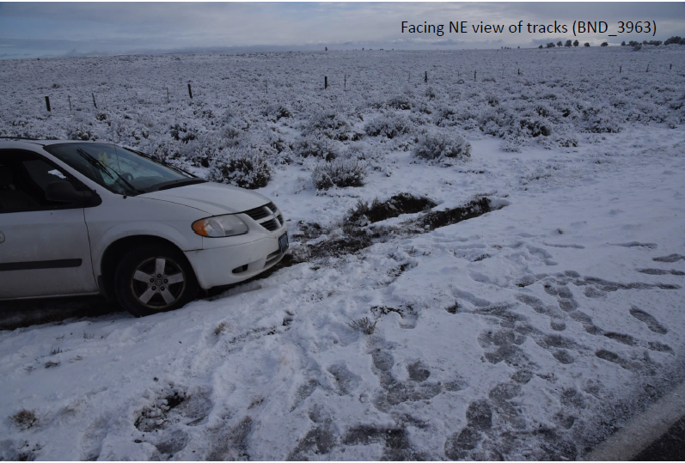
Based on all the available evidence, Sgt. Russell and Officer Williams’ belief that Ms. Bower was using deadly physical force against Officer Umnitz was objectively reasonable. Because of this, Sgt. Russell and Officer Williams’ decision to use deadly physical force against Ms. Bower was authorized by Oregon’s self-defense law.
LEGAL CHARGES
Ms. Bower will be charged in late May with the crimes of driving under the influence of intoxicants, fleeing or attempting to elude a police officer, reckless driving, and six counts of recklessly endangering another person. She is not charged now due to my desire to limit court hearings due to the risk of COVID-19.
Ms. Bower is presumed innocent of these charges, and in fact is innocent of these charges, unless and until the State proves her guilt beyond a reasonable doubt.
WHY?
How did it come to be that Ms. Bower was outside her minivan at the entrance to St. Charles Hospital, covered in blood, and acting erratically? Why did she flee when contacted by Officer Koehler?
Detectives and I worked hard to answer these questions. Here’s what we know: Back at Ms. Bower’s house, what police found was unusual. When officers arrived at her house at 3:30 a.m., they found two adult males, Ms. Bower’s fiancé, Stephen Horne and another adult male, Joshua Mondragon, as well as two small children ages 6 and 2.
The officers saw blood on the ground in the living room and droplets of blood, and smeared blood, throughout the house. Mr. Horne had been drinking, was highly intoxicated and had dried blood on his lips and hands. Mr. Mondragon had blood on his face, hands and body and was highly intoxicated, to the point of near-incoherence. Mr. Mondragon tried to take a shot of vodka while the officers were talking to him. The officers had to take the glass from him and told him he could not drink any more.
When Mr. Horne was told by the police that they were looking for Ms. Bower, he said she was not home and he asked what was going on. When asked if she drove a white minivan, Mr. Horne said she did and motioned toward the street, where there was an empty parking spot. He said he assumed Ms. Bower was driving it.
When Mr. Horne was asked what happened earlier in the evening, he explained that Mr. Mondragon had come over to his and Ms. Bower’s house earlier in the evening and that they had all been drinking. Mr. Horne said that at some point during the evening, Mr. Mondragon had become “wasted” and started “going crazy.” He said Mr. Mondragon had tried to fight him. Mr. Horne said that at some point during the struggle, Mr. Mondragon went crazy and attacked both he and Ms. Bower. Mr. Horne said that he had to choke Mr. Mondragon out. Mr. Horne said that Ms. Bower left while he was fighting Mr. Mondragon, but he was not sure how long that had been.
When receiving care at the hospital, Ms. Bower told her caregivers that she, Mr. Horne, and Mr. Mondragon had all been drinking at her house, that Mr. Mondragon had become violent, that she got between Mr. Mondragon and Mr. Horne, and Mr. Mondragon struck her.
Mr. Mondragon explained that when he woke up, he was told by Mr. Horne that he had hit Ms. Bower.
Ms. Bower’s blood alcohol level at the hospital was .277 (more than three times higher than Oregon’s per se DUII legal limit) at 5:39 AM, which was approximately three hours after she left her home. There is no evidence Ms. Bower drank alcohol after she left her home, so her blood alcohol level was likely even higher when she was at home.
Additionally, Ms. Bower’s nose was broken, and there is no evidence this injury was sustained during her encounter with law enforcement officers.
Detectives and I investigated this incident at the Bower home with an eye toward determining if one or more of the three involved people committed a crime. Was someone unwittingly drugged? Did someone assault another person? Did two or more people engage in a conspiracy to commit a crime?
At the end of the day, we don’t know what happened. The three witnesses were extremely intoxicated, to the state of near incoherence, so their statements are unreliable. Toxicology results from all three show no drugs other than alcohol in their systems. And the physical and forensic evidence, in the absence of one or more reliable witnesses, does not tell us the complete story.
It’s reasonable to assume that a drunken scuffle occurred for an unknown reason and this is what caused Ms. Bower’s broken nose, but this is a mere assumption. Unfortunately, this is one of those cases where the fog of intoxication results in the involved parties and the public not knowing for sure what happened.
But why did Ms. Bower flee from the officers outside the emergency room at the hospital? One possibility is that she knew she had committed the crime of driving while under the influence of intoxicants and did not want to be arrested for that (and in fact, Ms. Bower told the officers this from her hospital bed). Another possibility is that she sustained a head injury during the incident at her house and this, coupled with her excessive alcohol consumption, resulted in her acting irrationally. This theory is supported by medical records that indicate Ms. Bower sustained a subarachnoid hemorrhage that evening that may have been the result of an assault at her house.
CONCLUSION
Danielle Bower, her fiancé, and their friend got together to enjoy some cocktails and to catch up. What should have been an enjoyable evening among friends turned into a dangerous and near deadly incident that put the lives of numerous law enforcement officers, drivers on our roads, security guards, and Ms. Bower, at risk, all because of the abuse of alcohol. I encourage all involved, and everyone in our community who is struggling with their use of alcohol, to reach out for help. In the past are the days our community viewed those who seek help for an addiction as somehow “weak.” Community members who acknowledge they need help controlling their use of alcohol or drugs are to be commended for taking the steps necessary to better their lives.
The Tri-County Major Incident Team, led by Oregon State Police Detective Sergeant Roberto Robles, with the Oregon State Police as the lead agency on this case, conducted a thorough and professional investigation and provided me all the evidence I required to conduct my legal analysis. The Redmond Police Department, Deschutes County Sheriff’s Office, Oregon State Police Forensic Laboratory, Jefferson County Sheriff’s Office, Prineville Police Department, and the Oregon Department of Transportation assisted with this investigation.
Chief Deputy District Attorney Stephen Gunnels assisted me in my review and his experience and insight were invaluable.
Please contact me if you have questions about my decision.

“Code 3” is the radio terminology used by law enforcement to refer to a response from officers using their sirens and overhead lights. In other words, an emergency response.
What Officer Oliveira and other officers discovered at her home was unusual, concerning, and will be discussed later.
Because, fortunately, Ms. Bower survived this incident, a detailed forensic analysis of her body was not conducted by her doctors and this is why the exact number of rounds that struck Ms. Bower is unable to be determined. When someone is killed and a criminal investigation into the death is conducted, a forensic autopsy is administered to determine the exact number of bullet wounds, the angle of entry of the bullets, and many other facts that were not investigated by Ms. Bower’s medical providers. These care providers’ sole duty was to provide Ms. Bower with exceptional medical treatment, and they did so in spades.

